**MIDHUN**

1. Hello World Program?

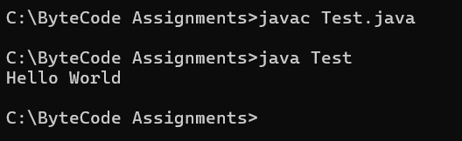

1. Addition of Two Numbers?

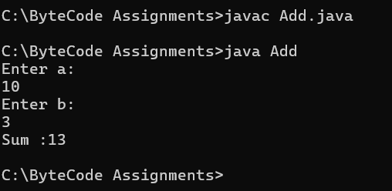

1. Check Even or Odd?

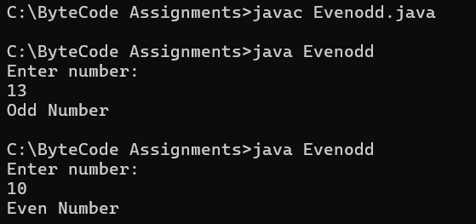

1. Find Largest of Two Numbers?

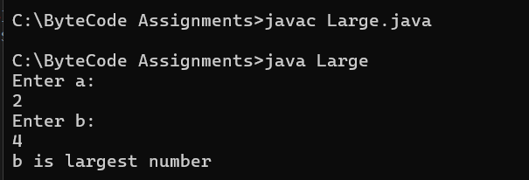

1. Factorial of a Number?

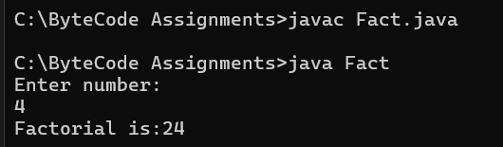

6. Run this Program using CMD

public class Hello {

public static void main(String[] args) {

System.out.println("Hello World")

}

}

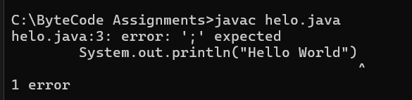

7. Run this Program using CMD

public class Hello {

public static void mian(String[] args) {

System.out.println("Hello Bytecode");

}

}

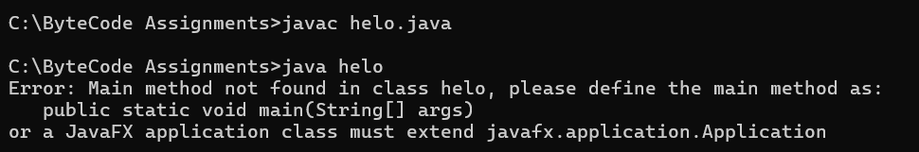

8. Run this Program using CMD

public class Sum {

public static void main(String[] args) {

int x = 5;

y = x + 2;

System.out.println(y);

}

}

